Category Overview
5:19:30PM
July 31, 2022
Unnamed Project
Time Units:
Replications:
30
Hours
Values Across All Replications
Key Performance Indicators
Average
All Entities

Non-Value Added Cost
0
Other Cost
0
Transfer Cost
0
Value Added Cost
0
Wait Cost
0
Total Cost
0
Average
All Resources
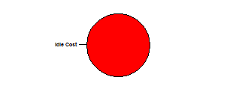
Busy Cost
0
Idle Cost
12
Usage Cost
0
Total Cost
12
Average
System
Total Cost
12
Number Out
41
Model Filename:
Page
of
1
11
6010\Klinik

Category Overview
5:19:30PM
July 31, 2022
Unnamed Project
Time Units:
Replications:
30
Hours
Values Across All Replications
Entity
Time
VA Time
Maximum
Average
Minimum
Average
Half Width
Average
Minimum
Value
Maximum
Value
0.3373
sick
0.02
0.2420
0.4803
0.03337049
1.1188
NVA Time
Maximum
Average
Minimum
Average
Half Width
Average
Minimum
Value
Maximum
Value
0.00
sick
0.00
0.00
0.00
0.00
0.00
Wait Time
Maximum
Average
Minimum
Average
Half Width
Average
Minimum
Value
Maximum
Value
4.0354
sick
0.25
2.9786
5.2839
0.00
11.2786
Transfer Time
Maximum
Average
Minimum
Average
Half Width
Average
Minimum
Value
Maximum
Value
0.00
sick
0.00
0.00
0.00
0.00
0.00
Other Time
Maximum
Average
Minimum
Average
Half Width
Average
Minimum
Value
Maximum
Value
0.00
sick
0.00
0.00
0.00
0.00
0.00
Total Time
Maximum
Average
Minimum
Average
Half Width
Average
Minimum
Value
Maximum
Value
4.3728
sick
0.27
3.2571
5.7642
0.03817298
11.7937
Cost
VA Cost
Maximum
Average
Minimum
Average
Half Width
Average
Minimum
Value
Maximum
Value
0.00
sick
0.00
0.00
0.00
0.00
0.00
NVA Cost
Maximum
Average
Minimum
Average
Half Width
Average
Minimum
Value
Maximum
Value
0.00
sick
0.00
0.00
0.00
0.00
0.00
Wait Cost
Maximum
Average
Minimum
Average
Half Width
Average
Minimum
Value
Maximum
Value
0.00
sick
0.00
0.00
0.00
0.00
0.00
Other Cost
Maximum
Average
Minimum
Average
Half Width
Average
Minimum
Value
Maximum
Value
0.00
sick
0.00
0.00
0.00
0.00
0.00
Transfer Cost
Maximum
Average
Minimum
Average
Half Width
Average
Minimum
Value
Maximum
Value
0.00
sick
0.00
0.00
0.00
0.00
0.00
Total Cost
Maximum
Average
Minimum
Average
Half Width
Average
Minimum
Value
Maximum
Value
0.00
sick
0.00
0.00
0.00
0.00
0.00
Model Filename:
Page
of
2
11
6010\Klinik

Category Overview
5:19:30PM
July 31, 2022
Unnamed Project
Time Units:
Replications:
30
Hours
Values Across All Replications
Entity
Other
Number In
Maximum
Average
Minimum
Average
Half Width
Average
sick
17.96
199.50
285.00
90.0000
Number Out
Maximum
Average
Minimum
Average
Half Width
Average
sick
3.17
41.4333
58.0000
27.0000
WIP
Maximum
Average
Minimum
Average
Half Width
Average
Minimum
Value
Maximum
Value
86.6590
sick
8.96
35.9599
131.60
0.00
234.00
Model Filename:
Page
of
3
11
6010\Klinik

Category Overview
5:19:30PM
July 31, 2022
Unnamed Project
Time Units:
Replications:
30
Hours
Values Across All Replications
Process
Time per Entity
VA Time Per Entity
Maximum
Average
Minimum
Average
Half Width
Average
Minimum
Value
Maximum
Value
0.04164271
Anjam Olaviyat dadan
0.00
0.04082411
0.04235781
0.03333464
0.04999666
0.6323
Khedmat dehi sathe1
0.02
0.5128
0.7363
0.3634
1.0831
0.3657
Khedmat dehi sathe2
0.00
0.3470
0.3849
0.2724
0.4595
0.2072
Khedmat dehi sathe3
0.01
0.1649
0.2549
0.1262
0.3277
Wait Time Per Entity
Maximum
Average
Minimum
Average
Half Width
Average
Minimum
Value
Maximum
Value
0.6709
Anjam Olaviyat dadan
0.10
0.2928
1.4593
0.00
3.1109
4.7960
Khedmat dehi sathe1
0.35
2.6775
6.4556
0.00
10.3012
4.8462
Khedmat dehi sathe2
0.28
3.2970
6.2201
0.00
10.5253
5.3530
Khedmat dehi sathe3
0.57
2.6750
9.2888
0.00
10.0199
Total Time Per Entity
Maximum
Average
Minimum
Average
Half Width
Average
Minimum
Value
Maximum
Value
0.7126
Anjam Olaviyat dadan
0.10
0.3343
1.5011
0.03340151
3.1605
5.4284
Khedmat dehi sathe1
0.36
3.3378
7.0469
0.4471
10.8311
5.2119
Khedmat dehi sathe2
0.28
3.6589
6.5808
0.2950
10.8268
5.5602
Khedmat dehi sathe3
0.57
2.8954
9.4568
0.1569
10.2279
Accumulated Time
Accum VA Time
Maximum
Average
Minimum
Average
Half Width
Average
Anjam Olaviyat dadan
0.65
7.6568
10.3296
3.7166
Khedmat dehi sathe1
0.44
4.7413
7.0576
2.2686
Khedmat dehi sathe2
0.45
6.1334
9.1928
3.6652
Khedmat dehi sathe3
0.13
0.8662
1.5980
0.1680
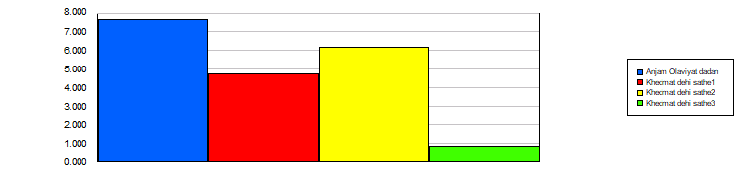
Model Filename:
Page
of
4
11
6010\Klinik

Category Overview
5:19:30PM
July 31, 2022
Unnamed Project
Time Units:
Replications:
30
Hours
Values Across All Replications
Process
Accumulated Time
Accum Wait Time
Maximum
Average
Minimum
Average
Half Width
Average
Anjam Olaviyat dadan
26.75
129.59
325.43
26.3492
Khedmat dehi sathe1
4.57
36.3537
59.8485
13.3876
Khedmat dehi sathe2
7.60
81.5191
125.36
39.7380
Khedmat dehi sathe3
3.54
21.8458
41.4967
8.0251
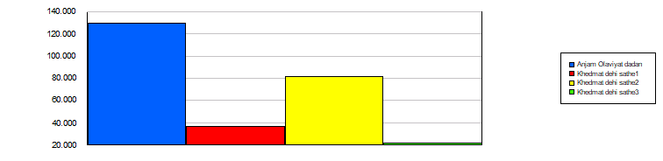
Total Accum Time
Maximum
Average
Minimum
Average
Half Width
Average
Anjam Olaviyat dadan
27.25
137.25
334.75
30.0913
Khedmat dehi sathe1
4.92
41.0949
66.2814
16.6890
Khedmat dehi sathe2
7.98
87.6525
134.55
44.1898
Khedmat dehi sathe3
3.65
22.7119
42.4328
8.6861
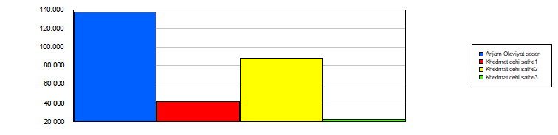
Cost per Entity
VA Cost Per Entity
Maximum
Average
Minimum
Average
Half Width
Average
Minimum
Value
Maximum
Value
0.00
Anjam Olaviyat dadan
0.00
0.00
0.00
0.00
0.00
0.00
Khedmat dehi sathe1
0.00
0.00
0.00
0.00
0.00
0.00
Khedmat dehi sathe2
0.00
0.00
0.00
0.00
0.00
0.00
Khedmat dehi sathe3
0.00
0.00
0.00
0.00
0.00
Model Filename:
Page
of
5
11
6010\Klinik

Category Overview
5:19:30PM
July 31, 2022
Unnamed Project
Time Units:
Replications:
30
Hours
Values Across All Replications
Process
Cost per Entity
Wait Cost Per Entity
Maximum
Average
Minimum
Average
Half Width
Average
Minimum
Value
Maximum
Value
0.00
Anjam Olaviyat dadan
0.00
0.00
0.00
0.00
0.00
0.00
Khedmat dehi sathe1
0.00
0.00
0.00
0.00
0.00
0.00
Khedmat dehi sathe2
0.00
0.00
0.00
0.00
0.00
0.00
Khedmat dehi sathe3
0.00
0.00
0.00
0.00
0.00
Total Cost Per Entity
Maximum
Average
Minimum
Average
Half Width
Average
Minimum
Value
Maximum
Value
0.00
Anjam Olaviyat dadan
0.00
0.00
0.00
0.00
0.00
0.00
Khedmat dehi sathe1
0.00
0.00
0.00
0.00
0.00
0.00
Khedmat dehi sathe2
0.00
0.00
0.00
0.00
0.00
0.00
Khedmat dehi sathe3
0.00
0.00
0.00
0.00
0.00
Accumulated Cost
Accum VA Cost
Maximum
Average
Minimum
Average
Half Width
Average
Anjam Olaviyat dadan
0.00
0.00
0.00
0.00
Khedmat dehi sathe1
0.00
0.00
0.00
0.00
Khedmat dehi sathe2
0.00
0.00
0.00
0.00
Khedmat dehi sathe3
0.00
0.00
0.00
0.00
Accum Wait Cost
Maximum
Average
Minimum
Average
Half Width
Average
Anjam Olaviyat dadan
0.00
0.00
0.00
0.00
Khedmat dehi sathe1
0.00
0.00
0.00
0.00
Khedmat dehi sathe2
0.00
0.00
0.00
0.00
Khedmat dehi sathe3
0.00
0.00
0.00
0.00
Total Accum Cost
Maximum
Average
Minimum
Average
Half Width
Average
Anjam Olaviyat dadan
0.00
0.00
0.00
0.00
Khedmat dehi sathe1
0.00
0.00
0.00
0.00
Khedmat dehi sathe2
0.00
0.00
0.00
0.00
Khedmat dehi sathe3
0.00
0.00
0.00
0.00
Other
Model Filename:
Page
of
6
11
6010\Klinik

Category Overview
5:19:30PM
July 31, 2022
Unnamed Project
Time Units:
Replications:
30
Hours
Values Across All Replications
Process
Other
Number In
Maximum
Average
Minimum
Average
Half Width
Average
Anjam Olaviyat dadan
17.96
199.50
285.00
90.0000
Khedmat dehi sathe1
4.76
45.5000
69.0000
23.0000
Khedmat dehi sathe2
9.02
110.53
144.00
52.0000
Khedmat dehi sathe3
0.79
14.8333
19.0000
10.0000
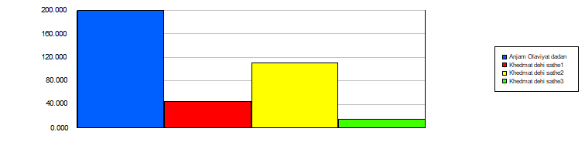
11
7
of
Page
Model Filename:
1.0000
8.0000
4.2000
0.65
Khedmat dehi sathe3
10.0000
25.0000
16.7667
1.21
Khedmat dehi sathe2
4.0000
11.0000
7.5000
0.68
Khedmat dehi sathe1
90.0000
247.00
183.83
15.65
Anjam Olaviyat dadan
Average
Half Width
Minimum
Average
Maximum
Average
Number Out
6010\Klinik

Category Overview
5:19:30PM
July 31, 2022
Unnamed Project
Time Units:
Replications:
30
Hours
Values Across All Replications
Queue
Time
Waiting Time
Maximum
Average
Minimum
Average
Half Width
Average
Minimum
Value
Maximum
Value
0.6721
Anjam Olaviyat dadan.Queue
0.10
0.2928
1.4559
0.00
3.1113
5.0854
Khedmat dehi sathe1.Queue
0.37
3.0381
6.8408
0.00
10.6703
4.9970
Khedmat dehi sathe2.Queue
0.27
3.2970
6.2201
0.00
10.7819
5.4776
Khedmat dehi sathe3.Queue
0.54
2.6750
9.2888
0.00
10.7899
Cost
Waiting Cost
Maximum
Average
Minimum
Average
Half Width
Average
Minimum
Value
Maximum
Value
0.00
Anjam Olaviyat dadan.Queue
0.00
0.00
0.00
0.00
0.00
0.00
Khedmat dehi sathe1.Queue
0.00
0.00
0.00
0.00
0.00
0.00
Khedmat dehi sathe2.Queue
0.00
0.00
0.00
0.00
0.00
0.00
Khedmat dehi sathe3.Queue
0.00
0.00
0.00
0.00
0.00
Other
Number Waiting
Maximum
Average
Minimum
Average
Half Width
Average
Minimum
Value
Maximum
Value
11.8424
Anjam Olaviyat dadan.Queue
2.49
2.1958
29.2847
0.00
80.0000
18.9816
Khedmat dehi sathe1.Queue
2.52
7.7083
34.5841
0.00
60.0000
46.3411
Khedmat dehi sathe2.Queue
4.77
16.7676
68.3434
0.00
129.00
7.8578
Khedmat dehi sathe3.Queue
0.54
4.5001
9.8029
0.00
11.0000
Model Filename:
Page
of
8
11
6010\Klinik

Category Overview
5:19:30PM
July 31, 2022
Unnamed Project
Time Units:
Replications:
30
Hours
Values Across All Replications
Resource
Usage
Instantaneous Utilization
Maximum
Average
Minimum
Average
Half Width
Average
Minimum
Value
Maximum
Value
0.9965
doktor
0.00
0.9958
0.9972
0.00
1.0000
0.6396
Parastar
0.05
0.3097
0.8636
0.00
1.0000
0.00
Resource doktor
0.00
0.00
0.00
0.00
0.00
Number Busy
Maximum
Average
Minimum
Average
Half Width
Average
Minimum
Value
Maximum
Value
0.9965
doktor
0.00
0.9958
0.9972
0.00
1.0000
0.6396
Parastar
0.05
0.3097
0.8636
0.00
1.0000
0.00
Resource doktor
0.00
0.00
0.00
0.00
0.00
Number Scheduled
Maximum
Average
Minimum
Average
Half Width
Average
Minimum
Value
Maximum
Value
1.0000
doktor
0.00
1.0000
1.0000
1.0000
1.0000
1.0000
Parastar
0.00
1.0000
1.0000
1.0000
1.0000
1.0000
Resource doktor
0.00
1.0000
1.0000
1.0000
1.0000
Scheduled Utilization
Maximum
Average
Minimum
Average
Half Width
Average
doktor
0.00
0.9965
0.9972
0.9958
Parastar
0.05
0.6396
0.8636
0.3097
Resource doktor
0.00
0.00
0.00
0.00
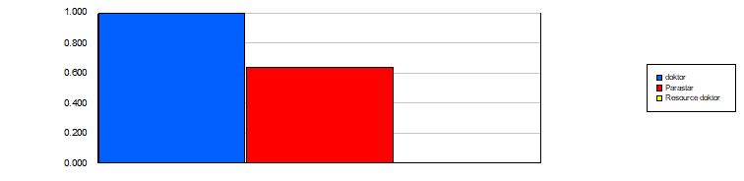
Model Filename:
Page
of
9
11
6010\Klinik

Category Overview
5:19:30PM
July 31, 2022
Unnamed Project
Time Units:
Replications:
30
Hours
Values Across All Replications
Resource
Usage
Total Number Seized
Maximum
Average
Minimum
Average
Half Width
Average
doktor
0.76
29.4667
34.0000
27.0000
Parastar
15.73
184.57
248.00
90.0000
Resource doktor
0.00
0.00
0.00
0.00
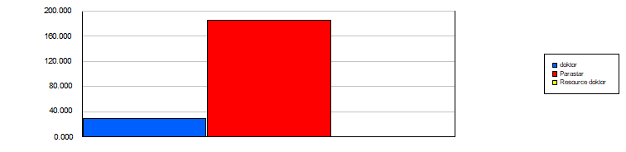
Cost
Busy Cost
Maximum
Average
Minimum
Average
Half Width
Average
doktor
0.00
0.00
0.00
0.00
Parastar
0.00
0.00
0.00
0.00
Resource doktor
0.00
0.00
0.00
0.00
Idle Cost
Maximum
Average
Minimum
Average
Half Width
Average
doktor
0.00
0.00
0.00
0.00
Parastar
0.00
0.00
0.00
0.00
Resource doktor
0.00
12.0000
12.0000
12.0000
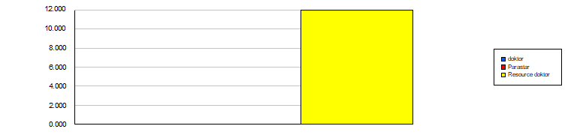
Usage Cost
Maximum
Average
Minimum
Average
Half Width
Average
doktor
0.00
0.00
0.00
0.00
Parastar
0.00
0.00
0.00
0.00
Resource doktor
0.00
0.00
0.00
0.00
Model Filename:
Page
of
10
11
6010\Klinik

Category Overview
5:19:30PM
July 31, 2022
Unnamed Project
Time Units:
Replications:
30
Hours
Values Across All Replications
User Specified
Tally
Expression
Maximum
Average
Minimum
Average
Half Width
Average
Minimum
Value
Maximum
Value
6.9500
Record Gabl az paziresh
1.54
0.00
15.5000
0.00
30.0000
Model Filename:
Page
of
11
11
6010\Klinik

